Brooks Trading Course
Section: How to Trade Price Action

video: 37A How to trade

2024.05.08 Wednesday

Low probability events trap traders into thinking the market is doing something it cannot do

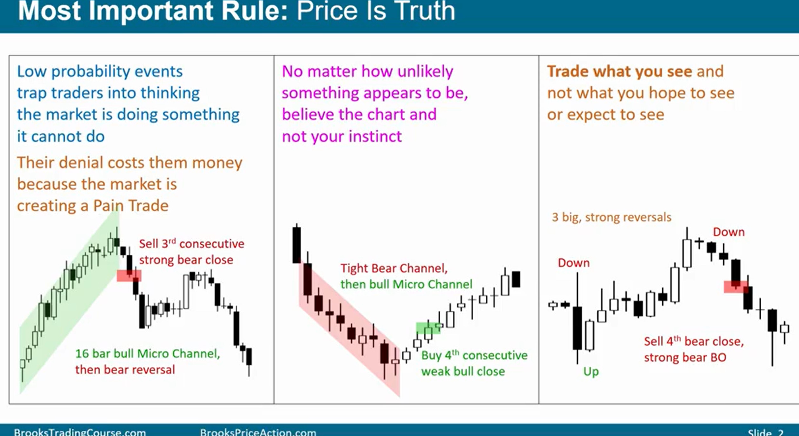
- price is truth. It doesn’t matter if it makes sense, if market is going down in strong trend, you have to sell – don’t question the market for what its doing

- As long as traders are in denial that the market is doing something, trader will experience pain, market is creating a Pain trade

- even if low probability event is unfolding, don’t be in denial and just look at the chart and believe the chart over your instinct. Trade what you see, not what you hope to see or expect to see.

What can markets do?
- Four types of price action in any given chart: 1) Breakouts, 2) tight channel 3) broad channel 4) trading range

1) Breakout 5~10% of bars in any chart
- strong momentum
- enter any time, for any reason and hold for swing (of course only in the direction of the breakout)

2) Tight channel
- once breakout begins to have pullbacks, it is in ‘channel’ phase
- if channel is tight, momentum is still strong and still is BO in higher time frame charts
- treat it like BO
- only enter with trend, especially on PB

3) Broad channel
(bull case)
- deeper pullback
- market temporarily becomes always in short but still forming higher highs and higher lows so still a bull trend
- bears can make money selling with limit/stop orders
- only look to sell for scalp but can hold for swing or scalp for buys
- (try to buy any pb around 50% of prior leg)

4) Trading range
- buy low, sell high (and mostly scalp: cover around middle of TR)
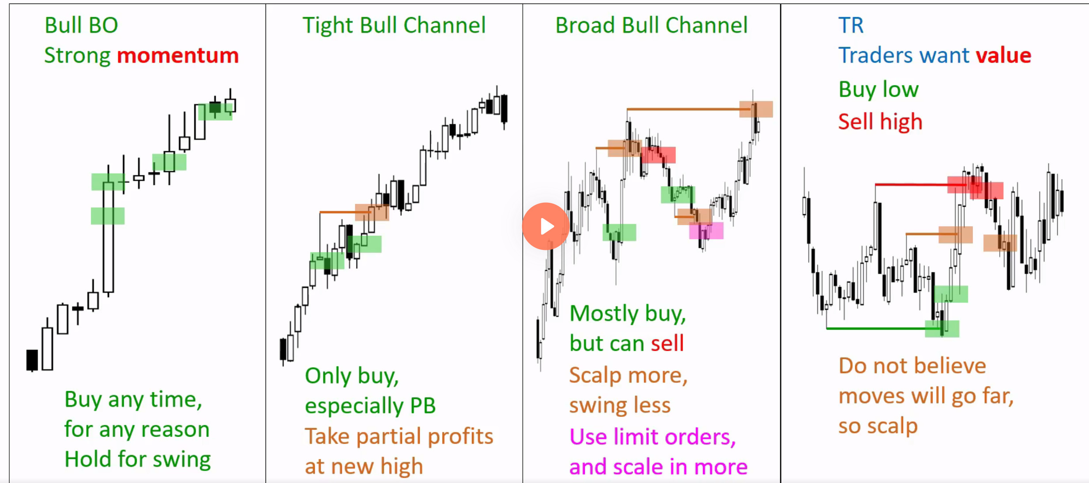
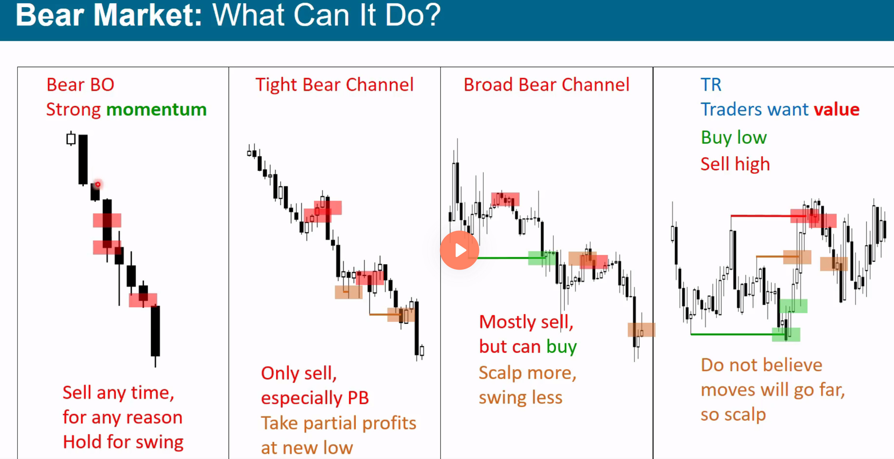

- Your success as trader as nothing to do with your personal qualities – if you are nice or work really hard, it doesn’t mean you deserve to make money

- Trading is hard! You are competing against the smartest people in the world

- You have to put in a lot of time in, more you know, the better you’re prepared to make money

- Key to making money is the ability to structure and manage trades

- In other words, deciding whether to bu or sell, how much to risk (where to put stop and where to take profit)

- There is no one way to trade – at any given time, there are multiple ways to trade that all makes mathematical sense

- If you think market is going down, it doesn’t matter if you take the first sell – there are countless ways to enter, the key is not your entry, the key is structuring your trades (eg what are you going to do if market goes against you, where your stop/target is, etc)

- There aer 81 bars on E-mini futures market per day and there is decent scalp setup for half of the bars

(conservative number is about 15~20 scalps for every 100 bars where you can make the minimum scalp size profit) but you have to know what you are looking for, how to structure and manage the trade.

- only 10% of the bars are in strong BO mode
- for remaining 90% of bars, its possible to structure profitable long and profitable short

rules are not that complicated.
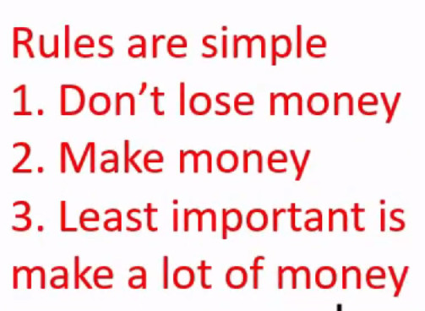
Focus on the first two rules – try not to lose money, don’t do anything stupid and try to make a little money

Summary of ‘How to Trade’

- Best way to trade is wait for strong signal bar and wait for appropriate stop (most traders should enter most of their trades using stops)

- Many reasonable entries, don’t need to take every one of them but as a trader you need to figure out some way to get into a trade

- It doesn’t matter where you entered, use appropriate stop (eg just above/below BO, major high/low, etc)
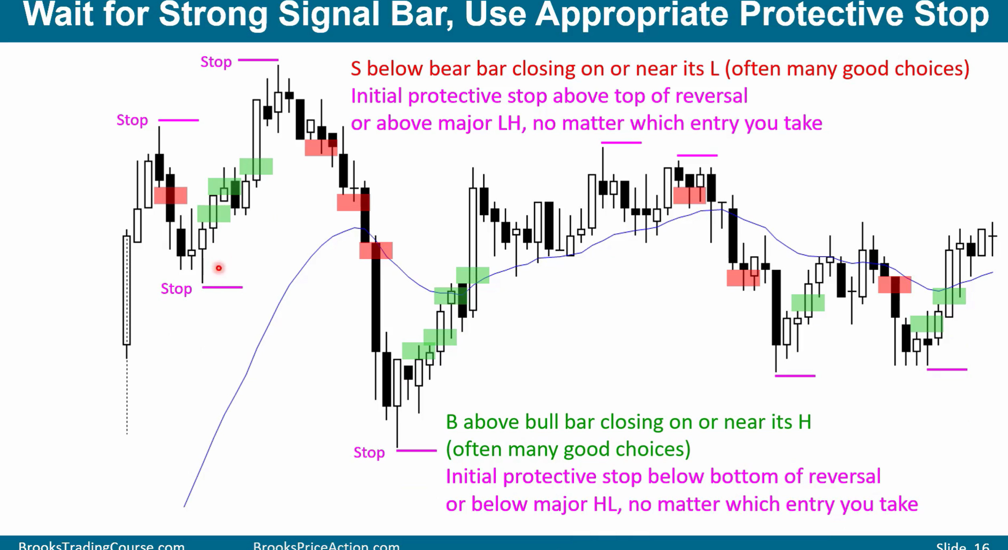
- In general, only risk 1~2% of account per trade certainly never more than 3% (including commissions and slippage).

- This applies for profitable trades (open position) open risk is still risk – if current price is more than 3% away from stop, reduce risk

– risk can be reduced by tightening stop but if there is no reasonable location for tighter stop, then reduce position size or cover entirely (then look to re-enter on PB if risk becomes appropriate).

-Beginning traders should only look for swing trades and they should mostly swing trade. That means they will typically to 1~3 trades a day.

- Only once they become consistently profitable, they can start looking for 3-10 trades a day and they can add some scalps if they would like

(In the encyclopedia, there is a classification of around ~100 patterns for swing traders: buy, sell, failed buy and failed sell so 400 in total)

